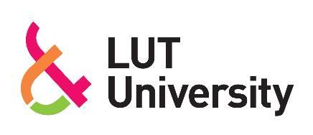

BUSINESS PLAN: NORDWIND SOLUTIONS
Solutions that move with the future

Lappeenranta–Lahti University of Technology LUT
2026
Md Saimur Rahman
Shoaib Iqbal Sirazi
Tareq Mahmud Bhuiyan
Yeaz Uddin Ahmed
Zayed Khan Alif

Table of Contents

1. Introduction to the business idea 3
2. Team Competence and Entrepreneurial Readiness 3
3. SWOT Analysis 5
4. Products and / or Services 6
5. Customers, Beneficiaries, and Stakeholders 7
6. Operating Logic 8
7. Operating Environment and Ecosystem 9
8. Vision and Long-Term Ambition 10
9. Impact strategy 11
References 13

Appendices
Appendix 1. Excel template with business calculations

Introduction to the business idea
NordWind Solutions is a proposed clean-energy project which develops and sells omnidirectional wind turbine systems to buildings in Lappeenranta. The company aims at assisting buildings to produce some of their own electricity locally by means of small wind turbines mounted on roof tops or on appropriate facades. The customers targeted by the business include those who have constant or high electricity demand such as housing companies, housing providers serving the students, assisted-living facilities, university buildings, and government-run properties.
The company provides a solution package and not a single device. The main product it offers is site analysis, system sales, installation, smart energy monitoring, maintenance and upgrades in the future. This generates value in three related aspects. First, it generates technical value by providing the possibility to generate local power on a building level. Second, it generates economic value by decreasing some of the reliance of the customer on the electricity that is bought in the grid, as well as developing a model of service that contributes to the effective performance of the system in the long term. Third, it generates strategic value by assisting customers in showing visible action of climate in the built environment. Value is provided in terms of evaluation, design, installation and after sales services and it is realized in combination of single project revenue and periodic service revenue.
NordWind Solutions is marketed as a complementary solution to the problem of urban buildings that is based on renewable-energy instead of a substitute to all the current alternatives. In high-latitude settings like Finland, the energy systems based on the sun have a significant seasonal mismatch, implying that renewable generation is not distributed evenly throughout the year without storage or similar technologies (Hirvonen et al., 2018). Simultaneously, the studies of the urban wind energy reveal that building-mounted systems, which are located in the built environment, should be evaluated, as turbulence, shielding, and local wind patterns significantly influence the performance. This helps the business logic of NordWind Solutions: rather than selling a uniform product to each location, the company focuses on site-specific evaluation and building-specific design as the key elements of its business proposal (KC et al., 2019; Walker, 2011).

Team Competence and Entrepreneurial Readiness
The founding team consists of complementary technical skills that are very relevant in the development of a building-integrated renewable-energy project. This interdisciplinary piece makes the venture more convincing as the solution offered will need expertise not only in sustainability and energy systems, but also in mechanical design, technical feasibility, and electrical integration. In the case of a small-scale business like NordWind Solutions, this is a big plus, as the business idea will hinge on the capacity to perceive the solution in a number of technical angles simultaneously.
Md Saimur Rahman is pursuing a course in Energy Technology, which offers a good background in energy systems, sustainability, and renewable-energy solutions. Such a background is especially pertinent since NordWind Solutions is poised to be a building-level clean-energy solution that needs to be considered not just as a product, but as a component of a broader energy-transition environment. His work assists the team in comprehending distributed generation, building energy use and the contribution of renewable technologies in minimizing the environment and reliance on centralized electricity systems.
Shoaib Iqbal Sirazi, Yeaz Uddin Ahmed and Zayed Khan Alif are from Mechanical Engineering. They have a good academic background which adds value to the knowledge in system design, materials and mechanical feasibility. These skills are extremely beneficial to a venture that focuses on wind-turbine systems because the effectiveness of the solution will rely on the sound, structural design, appropriate material selection, durability, and the realistic abilities to incorporate the system into the buildings. their input enhances the capacity of the team to evaluate the capability of the proposed turbine system to operate in a reliable and safe manner in the targeted urban setting.
Tareq Mahmud Bhuiyan is pursuing Electrical Engineering which has equipped him with the knowledge in the generation of electricity, power systems, and energy distribution. This knowledge is also critical since the business concept does not involve just the physical turbo device, but encompasses the production, distribution, monitoring, and utilization of electricity in building energy systems. His experience enhances the capacity of the team to know how the proposed solution relates to the electrical infrastructure, how the power generated can be controlled and how the system would assist in the overall functionality of the building.
Collectively, these backgrounds form a technically balanced team of an early-stage clean-energy venture. The interdisciplinary approach of Energy Technology, Mechanical Engineering and Electrical Engineering gives a good foundation to access the concept in its sustainability relevancy, mechanical functionality and electrical compatibility. This interdisciplinary setup enhances the maturity of the venture to build a technically viable and meaningful business model that is environmentally good. It also strengthens the funder case, because the team can demonstrate that the idea is supported by complementary technical knowledge rather than by a single-discipline perspective.
Besides technical competence, the team exhibits entrepreneurial preparedness by the willingness to be realistic about the venture. Urban wind in buildings is not a consumer-product business. It requires technical judgment, customer trust, testing, and continuous learning. The preparedness of the team thus does not just lie in the availability of the available academic knowledge, but also its capacity to work in a team, respond to feedback, and forge external alliances where internal competence is yet insufficient. This plays a crucial role especially in impact entrepreneurship, where credibility of the business and value to the society is directly linked to the quality of implementation.
Meanwhile, there are still several competence gaps. These are high level wind-resource evaluations, elaborate structural certification to be integrated with a rooftop or facade, regulatory compliance and institutional sales between businesses to businesses. These loopholes are crucial yet can be handled. The team will tackle them by engaging external professional staff like structural engineers, licensed installers, and technical advisors and also by learning on the job and ongoing skills training by pilots. This is not only a sign of technical potential, but also of entrepreneurial maturity, since the team is aware of its strengths, as well as its weaknesses, and has a realistic approach to fill in the gaps that exist.

SWOT Analysis
Analysis of the strategic position of the enterprise from both business and impact perspectives.

Strengths
- Local power based on renewable electricity that is evidently sustainable and has its value proposition.
- Product-service business model is made up of hardware, installation, monitoring and maintenance.
- Site analysis was provided as a service, and this lends technical authority.
- High level of relevance with climate-transition and building-decarbonization trends.
- Possible transferability to institutional clients who like to see something being done on sustainability.
Weaknesses
- Extremely new company with no local installation history.
- A small amount of actual performance of the target local buildings is available.
- Depending on outside technical specialists in structural and electrical certification.
- Delay in decision making of housing companies and customers of the public sector.
- The trust of the customers should be established gradually, since urban small wind is not as popular as solar PV.
Opportunities
- Further pressure on the owners of the building to improve their performance in terms of environment.
- Gaining popularity of distributed and on-site renewable-energy solutions.
- Potential pilot projects housing associations, university actors or government institutions.
- Potential to find wind to supplement solar in latitudinally high areas.
- Growth to monitoring, optimization and service contracts on long term basis.

Threats
- Some of the urban sites may also not have good wind conditions that can be utilized to generate a viable performance.
- The customers may not be interested in noise, vibrations, safety or maintenance.
- Solar and heat pump, efficiency retrofits and competition of smart energy-management system.
- Restricting and legal obstacles to building integration.
- Risk of reputation whereby case systems are sold to the wrong places.

Products and Services
The omnidirectional wind turbine system mounted on a building is the main product of NordWind Solutions. The figure below shows the omnidirectional wind turbine system.
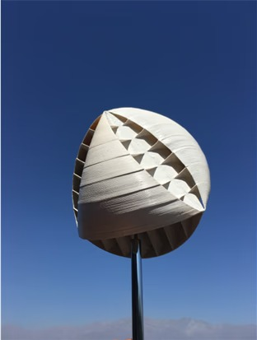
Figure 1: omnidirectional wind turbine system (O-Innovations | Home to O-Wind, n.d.)
It is intended to transform the wind into electricity in urban environment where the direction of the airflow can be changed, and buildings can accommodate distributed generation technologies. To the customers, the system has a potential of renewable energy generation, some minimization of grid reliance, and diversification of the buildings energy strategy.
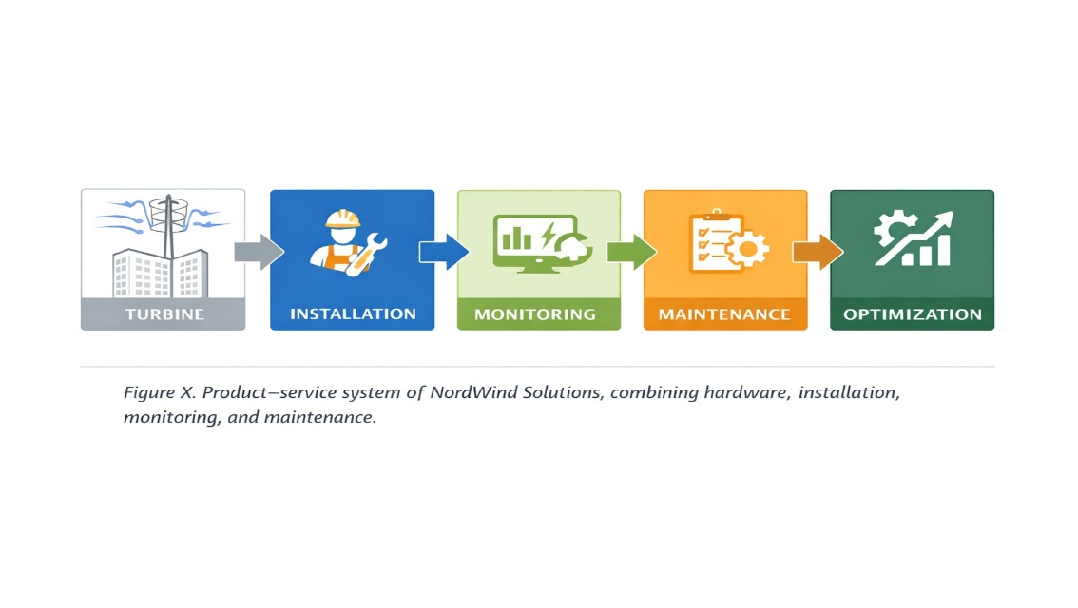
Figure 2: NordWind Solutions’ integrated product–service ecosystem.
The installation service is necessary since institutional customers would not normally embrace technical systems without a definite implementation roadmap. With the product plus installation assistance, NordWind Solutions will minimize the interest-to-adoption barrier. Installation also generates direct project revenues and assists the company to maintain control of quality in the implementation of the solution.
The maintenance service helps to maintain reliability, customer trust and continuity of impact. Only when a solution to a renewable energy is viable in the long run does it add value. Maintenance thus adds to the relationship with customers in the long term and to the plausibility of the environmental claims of the company.
The intelligent energy monitoring system provides the customers with insights into the output of the system and the performance of the system. Monitoring enhances transparency, promotes reporting and further service layer to hardware sales. It can also help to optimize and upgrade decisions in the long-term.
One of the most strategic services is the consultation and site-analysis service. Literature in the academic literature on building-mounted and small urban wind systems demonstrates that the turbulence, shielding and highly site-specific flow properties are the major determinants of wind conditions in the built environment. This implies that the business cannot afford to consider each and every building as equally appropriate. Rather, NordWind Solutions generates value by finding the right location, shunning technically flawed installations, and gaining confidence in the decision by customers prior to investing capital. The logic enhances the business model and the funder case since it minimizes technical and reputational risk (KC et al., 2019; Walker, 2011).

Customers, Beneficiaries, and Stakeholders
NordWind Solutions customers are mainly organizations that are charged with energy solutions regarding buildings. They are housing companies, student housing providers, like LOAS, assisted-living organizations, like Aspakoti, large residential property owners, like SATO and Lumo, building operators in the public sector, and facilities that are related to universities. The attractiveness of these customer groups is that they operate properties that have sustained energy needs and because the customers of these groups usually experience cost pressure as well as sustainability pressure.
The main beneficiaries are not only limited to the paying customer. They involve the building owners, the facility managers, residents and the building users who may be interested in enhanced environmental performance, increased visibility of local energy generation and potential cost saving in the long run. On a larger scale, more apparent implementation of decentralized renewable-energy technologies can also be beneficial to the local community.
The influence of the customers is likely to be a mixture of factors: interest in diminishing the energy-related operating expenses in the long run, the motivation to enhance the environmental profile of the building, readiness to take part in the process of innovation, and the reputational cost of the visible climate action. Nevertheless, the obstacles towards adoption are also high. The customers can not be sure that the solution will work in their location, building structure is appropriate, how the maintenance would be worked and the payback logic would be credible. Such obstacles render trust-building to be at the center of the company strategy.
Structural-engineers, electrical-contractors, installation-partners, monitoring-technology providers, municipalities, university networks, pilot-hosts and funders are other important stakeholders. Ethics is a subject of concern. NordWind Solutions should not over promise performance, should tell the truth about technical limitations, and should recommend installations where it is appropriate by the conditions of the site. The recent review literature on urban wind energy harvesting also indicates that the environmental impacts, and the context of the local implementation should be taken into consideration. This helps in the focus of the company on responsible deployment, as opposed to aggressive generic sales (Tsionas et al., 2025).

Operating Logic
NordWind Solutions work in a progressive commercial and technical procedure. The initial phase is identification and generation of leads to the customers. The company comes to prospective target customers via direct outreach, networks, pilot discussions, and business-development discussions. In the case of a new venture in this sector, the customer acquisition process is more likely to be relationship oriented compared to being transactional.
The second step is site analysis and consultation. This is where the company will assess the technical suitability of a building of a customer with the solution offered. In case it seems to be a good location, NordWind Solutions is ready to create a specific proposal which can comprise turbine hardware, installation, monitoring, and maintenance. This will turn the company into a generic hardware vendor into a solution provider.
The third one is delivery. A set of internal project management and external specialist partners are involved in coordinating system installation, including structural consultants and electrical installers. The fourth phase is post-installation service also comprising of monitoring, maintenance and support. This service logic is a commercially significant factor as it generates a recurring revenue and enhances customer retention.
The business model thus includes one time streams of revenue as equipment and installation and recurrent streams of revenue as service contracts and monitoring. This is appealing in investor/ funder sense in that it lessens reliance on a single sale and generates the potential of a more enduring customer lifetime value than a single sale.
The venture operates on the basis of key partnerships. NordWind Solutions will not attempt to develop all capabilities internally and start with the basics but will depend on the chosen technical partners to minimize the execution risk, enhance compliance, and improve the delivery quality. The customer acquisition and building assessment are the initial two stages in the value chain which is followed by system design and procurement, installation, monitoring and maintenance. This reasoning can be applied in phases since it enables the corporation to test the demand and operations and then expand.

Operating Environment and Ecosystem
NordWind Solutions is working in a wider eco system that is influenced by climate transition, distributed energy, digital energy management and growing demands on buildings to minimize emissions. Such trends provide the company with a good strategic background. They however do not do away with competition. The venture ventures into a market where the building owners already are aware of the alternative like solar PV, heat pumps, energy-efficiency retrofits, and smart building-control solutions.
That is why, the wind technologies are not the only real competitors of the company. It also covers all other possible spend options by a property owner to enhance energy performance or sustainability performance. This implies that NordWind Solutions should not just compete based on technical novelty, but also be relevant to the customer, have practical credibility, and the quality of its model of implementation.
The scholarly materials of urban wind support this aspect. Small wind systems mounted on the buildings and building-mounted wind systems may be applicable to the built environment, but the performance of these systems is highly reliant on the local wind conditions, turbulence, and locale-specific factors.
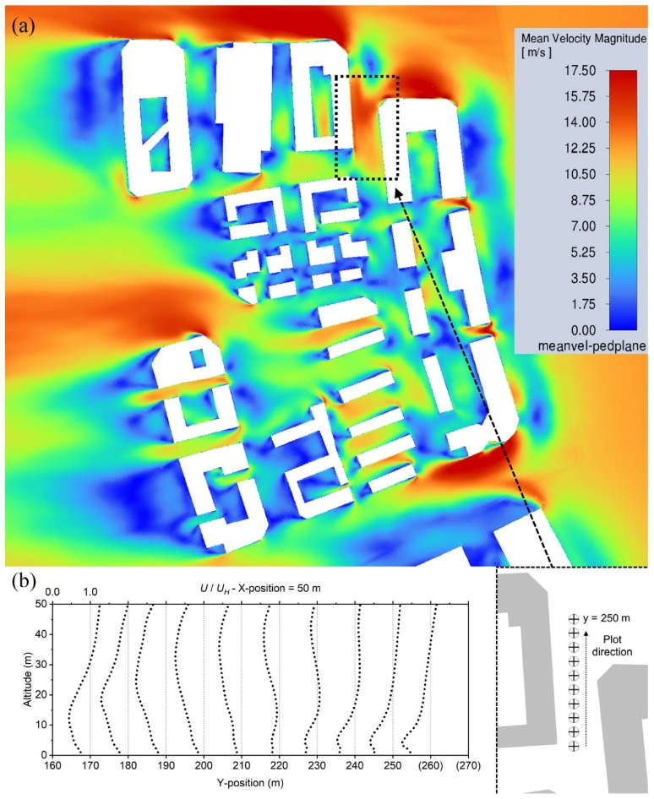
Figure 3: CFD in Urban Wind Resource Assessments (Chu & Wang, 2025).
Such technical realities make the ecosystem challenging, yet provide a competitive gap to a venture that is disciplined, assessment-based and open in dialogue with its customers. When a business has a blend of renewable-energy ambition and technical realism it will most likely gain the trust of institutional customers and funding bodies.
The topical megatrends are climate change, digitalization, distributed energy, and the rising significance of visible ESG performance of the property sector. These tendencies facilitate business long-term strategic logic, yet, they increase demands in terms of demonstration, control, and responsibility. NordWind Solutions can leverage that into its benefit by becoming an evidence-based provider of building-specific urban wind solutions as opposed to being a generic equipment reseller.

Vision and Long-Term Ambition
NordWind Solutions hopes to be a reputed supplier of building-integrated urban wind solutions in Finland within three to five years, starting with pilot and early commercial installations in Lappeenranta. The long term aspiration of the company is not to go large by all means, but to develop a reputation of technically plausible deployment, accountable customer counseling as well as quantifiable sustainability worth.
The venture aims to fill a certain gap within its ecosystem: a gap between sustainability aspiration and the built environment practice. Under this status, NordWind Solutions would be a company which assists property owners in the decision of when urban wind can be used, how it could be used responsibly, and how the performance could be measured over time.
The legacy that the company hopes to leave is a business and social one. In a business-like, it tries to demonstrate a feasible product-service model that is based on site analysis, equipment, installation and recurring service revenue. At the societal level, it aims to add to more decentralized and visible adoption of renewable-energy in buildings, as well as accumulate evidence of where urban wind is actually effective and ineffective. This evidence based positioning may be used to replicate in other cities in Finland with similar building profile and climate.
Some of the growth opportunities are to expand to other types of buildings, expand to other cities in Finland, bring it even closer to smart energy-management solutions, and increase the recurring-revenue base with monitoring and maintenance services. This is appealing to a funder as the expansion is associated with proven capability and replicable logic of service, rather than unsubstantiated beliefs of prompt expansion.

Impact strategy
An impact strategy is an explanatory approach of how a business or organization strives to attain and quantify its social, environmental, or economic objectives. It transcends the conventional approach to business in that it focuses on achieving good results to people, the planet, and societies.

- Quantifying the problem

The solution of NordWind Solutions tackles a more systemic issue: constructions require a feasible means to cut down on emissions, enhance localized renewable energy production, and decrease their reliance on centralized energy infrastructure. Solar-based systems in high-latitude climates (like Finland) are not adequately matched to the season and so renewable generation is ultimately not as available throughout the year without storage or additional technologies (Hirvonen et al., 2018). This does not imply that solar is worthless, it just underlines the rationale of venturing into other distributed renewable sources to fit apt settings. NordWind Solutions answers this challenge by providing a building-integrated wind solution which is specifically aimed at the built environment.
Meanwhile, the problem is defined in the company in a careful manner. It is not just an issue of shortage of turbines. The problem is that there are no technically plausible, location-specific and socially responsible, site-based wind-energy solutions to buildings. This framing is significant as it brings the impact strategy of the company up to the same level with both the ambition and the quality of implementation.

- SMART goals and measurable metrics
NordWind Solutions has established its clear and measurable impact goals in the first three years of operation after identifying the problem. This is to make sure that, the environmental contribution of the venture is to be monitored in a realistic and open manner.
An appropriate SMART goal of NordWind Solutions is as follows:
NordWind Solutions seeks to achieve at least 10 building site analyses, installation of at least 3 appropriate buildings in Lappeenranta with pilot or commercial omnidirectional wind turbine systems and production of at least 1000 kWh of local renewable electricity with support of monitoring and maintenance services by the end of year 3.
This objective is specific as it aims at site studies, installations, and local generation of renewable electricity in a particular area. It is quantifiable in the sense that the progress can be monitored by the number of buildings that have been assessed, the number of systems in place and the quantity of electricity that has been produced. This is feasible since the business is beginning with a targeted customer base and gradual pilot-based strategy. It is pertinent since it contributes directly to the viability of the business and its environmental effects. It is time-related as it will be during the initial three years of the business.
NordWind Solutions will measure the following quantifiable measures to quantify results:
- At least 10 site analyses completed by the end of year 3
- Minimum of 3 pilot or commercial installations by end of year 3.
- 100 percent connected customers who are on a monitoring system.
- Retention of installed customers in maintenance/service contracts of at least 80%.
- Annual renewable electrical energy (kWh) produced per installed system.
- Projected decrease in bought grid electricity (percentage) to participating buildings.
- CO2e reduction (kgCO2e/year) calculated by dividing the actual generation by a transparent electricity-emission factor.
This requires baseline measurement to determine whether the impact is created. Prior to any installation, NordWind Solutions will record the present state of the building, its present level of electricity usage, the presence of renewable-energy usage, and the lack of local generation based on wind. This baseline will be tracked after installation as compared to monitored system output, purchased grid electricity changes and system operation time. This will allow determining whether the venture is producing quantifiable environmental benefits as opposed to selling technical equipment only.

- Relevant indicators to measure the impact

To measure the meaningfulness of the impact NordWind Solutions makes, the company has to employ indicators that are directly related to the actions of the company and the desired results. Since the business is aimed at developing renewable-energy solutions that are built-in buildings, the environmental and economic indicators are the most significant, whereas the social ones are secondary.
The most important environmental indicators are:
- Power per installed turbine systems (kWh/year) of the generated renewable electricity (annually).
- Projected savings in electricity (percent) that will be bought in participating buildings.
- Calculated CO2e reduction (kgCO2e/year) through known electricity production and a suitable electricity-emission factor.
- Count of structures with local wind-generated electricity.
These factors are pertinent since the essence of the venture is to boost local production of renewable energy and to cut down on the amount of electricity that is bought out. Of these, the most powerful indicators of the desired impact of the venture on the environment are annual renewable electricity generation and the approximated CO2e reduction.
The most important economic indicators are:
- Amount of paying customers.
- The sales of revenue of system sales, installation and maintenance services.
- Recurring revenue of monitoring and maintenance contracts that occur every month.
- Retention rate of customers in service contracts.
- This can be calculated transparently, estimated energy-cost savings (€ per year) of participating buildings.
Such indicators are applicable since they indicate the viability of the business model and that customers get useful economic value out of the solution. Because NordWind Solutions is not a strictly charitable project, but an impact business, it would be imperative to have the economic viability to maintain the environmental impact in the long run.
The most applicable social indicators, in this case, are more limited, yet they might include:
- Pilot partnerships established with local institutions.
- Count of buildings where visible local renewable-energy solutions are of benefit to users.
- Customer feedback: satisfaction, or trust of stakeholders in the event of a systematic collection of customer feedback.
These social indicators are secondary to the environmental indicators though they could be helpful in showing whether the venture enhances the awareness, trust and acceptance of decentralized renewable-energy solutions in the local community.
Practically, NordWind Solutions must focus on a few good indicators instead of attempting to determine everything simultaneously. The core indicators set (first three years) would be realistic and include:
- per capita annual renewable electricity production (kWh/year)
- estimated reduction of CO2e (kgCO2e/year)
- number of systems installed.
- percent decrease in purchased grid electricity of participating buildings.
- repeat customer and revenue of the service.
This combination is appropriate since it not only embodies the environmental nature of the venture, but the economic reason why the impact can be sustained over time.

- Theory of Change
The Theory of Change of NordWind Solutions outlines how the company resources and activities can result in short-term outcomes that can be measured and long-term impact. The rationale starts with technical expertise, alliances, and funding, and proceeds to site evaluation, installation, and energy provision to local generation of renewable energy and less reliance on purchased grid power.
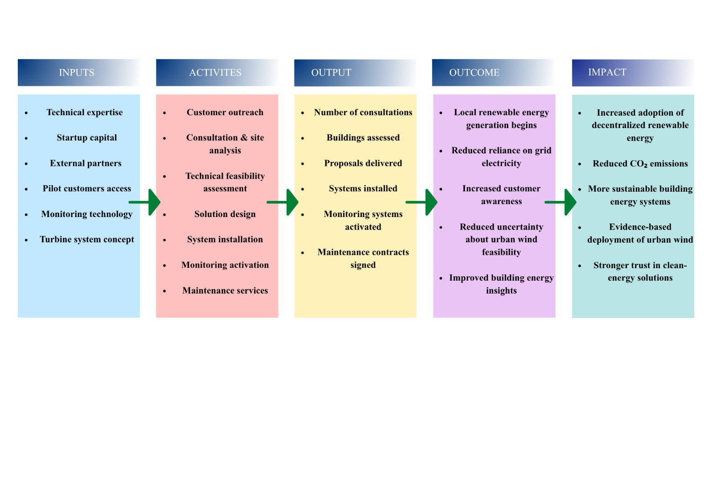
Figure 4: Theory of Change of NordWind Solutions: from inputs and activities to measurable outputs, short-term outcomes, and long-term environmental impact.
Here is the details breakdown of every steps:
- Inputs
The technical expertise of the founding team, the startup capital, the collaboration with structural and electrical specialists, the reach to the pilot customers, the monitoring systems, and the capacity to install the turbines and the concept of the turbine-system are the key inputs of the NordWind Solutions. Such inputs are needed since the business will need not only technical capacity, but also external assistance to transition between concept and implementation.
- Activities
Customer outreach, consultation, site analysis, technical suitability assessment, solution design, system installation, monitoring activation and maintenance delivery are the primary activities of the venture. Such activities are also directly related to the business model since NordWind Solutions does not sell equipment only, but also offers assessment, implementation and follow-up services.
- Outputs
Immediate outputs of these activities include the number of consultations made, the number of buildings examined, the number of proposals given, the number of turbo systems installed, the number of monitoring systems turned on, and the number of maintenance contracts signed. These are tangible and quantifiable outputs that indicate the success of the company in the provision of its services.
- Outcomes (short-term changes)
The short-term benefits are that building owners will have access to a local source of renewable-electricity production, they will learn more about the energy performance of their buildings, and will no longer be uncertain about the potential of urban wind to work in their building situations. Moreover, the customers can also start cutting down some of the purchased grid power by means of produced locally generated power. Meanwhile, the company develops technical and commercial learning based on every project, enhancing the delivery quality in the future.
- Impact (long-term changes)
The long-term effect is the greater implementation of appropriate decentralized renewable-energy systems in buildings, more local generation of clean energy, and the move towards more sustainable building energy systems. NordWind Solutions, in the long term, will strive to become a contributor to environmental sustainability by assisting in decreasing reliance on electricity provided externally and aiding the climate shift in the constructed environment. On a bigger scale, the venture can also be used to build trust in renewable-energy solutions of urban properties, which are carefully evaluated and evidence-based.
The Theory of Change is appropriate since it relates the practical business operations of the venture and its desired environmental impact in a rational step-by-step fashion.

References
Chu, R., & Wang, K. (2025). CFD in Urban Wind Resource Assessments: A Review. Energies 2025, Vol. 18, Page 2626, 18(10), 2626. https://doi.org/10.3390/EN18102626
Hirvonen, J., ur Rehman, H., & Sirén, K. (2018). Techno-economic optimization and analysis of a high latitude solar district heating system with seasonal storage, considering different community sizes. Solar Energy, 162, 472–488. https://doi.org/10.1016/J.SOLENER.2018.01.052
KC, A., Whale, J., & Urmee, T. (2019). Urban wind conditions and small wind turbines in the built environment: A review. Renewable Energy, 131, 268–283. https://doi.org/10.1016/J.RENENE.2018.07.050
Tsionas, I., Llaguno-Munitxa, M., & Stephan, A. (2025). Environmental effects of urban wind energy harvesting: a review. Buildings and Cities, 6(1), 1–24. https://doi.org/10.5334/BC.491
Walker, S. L. (2011). Building mounted wind turbines and their suitability for the urban scale—A review of methods of estimating urban wind resource. Energy and Buildings, 43(8), 1852–1862. https://doi.org/10.1016/J.ENBUILD.2011.03.032

Appendix 1. Excel template with business calculations
The business calculations are done in the completed Excel workbook that can be attached as a separate file. It consists of the financial calculation sheet, profitability calculation sheet and monthly sales calculation sheet.

